**PIZZA ORDERING SYSTEM**

**CONTENT:**

* ABSTRACT
* INTRODUCTION
* REQUIREMENT SPECIFICATION
* ARCHITECTURE DESIGN
* CONCLUSION AND FUTURE WORK
* REFERENCES

**ABSTRACT**

In This Project I developed a system where we can make a pizza order to the registered users and also allow the user to modify order. User should give accurate credentials to login into portal, after login user is allowed to place order. At the time of placing order it asks about the customer details like name, address, phone number and topping, once user click on place order it generates order id and save the details. User also can view his/her order details which contains amount , date of order and topping. User can also delete the order by entering his order id and click on delete button. After successfully placing order user can logout from portal.

**INTRODUCTION**

The Online Ordering System can be defined as a simple and convenient way for customers to purchase food online, without having to go to the restaurant.]

**Project Objective:**

The Main purpose of this online ordering system is to provide user to make an order from their home without going to restaurant. This Project allows user to place order by giving User details which are stored in database and it will generate an order id for every order. Registered user can login into portal by giving credentials and place an order and the information is stored in the database. After placing an order if user wants to modify or delete he/she can choose delete or modify which will be reflected in database. User can also review the order details by enter order id in display order option; if order id is not available in database then it shows an error. There is an option to delete order in which user should enter order id and delete it. So this option allow user to change order details or to delete the order.

Pizza Ordering System (POS) is a web application allows user to place an order. The main goal of this software is to store, manage and consolidate the registration data.

The system allows only registered user to login in the website. This is a web application developed in Java, Jsp and SQL server. User has to provide his/her credentials to login in portal and place order by giving details like topping, address, name and phone number and these details are stored in database. After that order id will be generated and amount is shown in page also stored in database. One user can give any number of orders which will generate unique ordered and customer id. User have options to modify, view and delete an order by order id, if order id is not available in database then is will show an error. After order placed user can logout from portal. This project provide most basic functionalities required for online ordering.

**REQUIREMENT SPECIFICATION**

* Programming Language: Java
* Front End: HTML5,CSS, JAVASCRIPT, JSP
* Database: MYSQL
* OS: Windows 7 or higher
* RAM: 4GB or higher
* Browser: Internet Explorer or Chrome
* Web Server: Apache Tomcat 7 and higher
* Tools: Eclipse
* Framework: Hibernate with Spring MVC

**ARCHITECTURE DESIGN**

**Project Modules:**

**Login**: Registered user can login into portal by giving correct credentials, if not login will be failed.

**Place Order:** Once Logged in user place the order by giving details like name, address and topping.

**Modify Order:** If the user wants to modify the order then by giving order id he can modify. If order id does not exist then it shows error.

**Delete Order:** If user wants to delete the order then by giving order id he can delete. If order id does not exist then it shows error.

**Display Order:** If user wants to display the order details then by giving order id he can view details. If order id does not exist then it shows error.

**Logout:** User can Logout from portal by clicking logout

**Use case Diagrams:**

**User:**

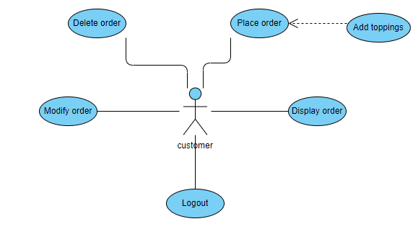

**Login:**

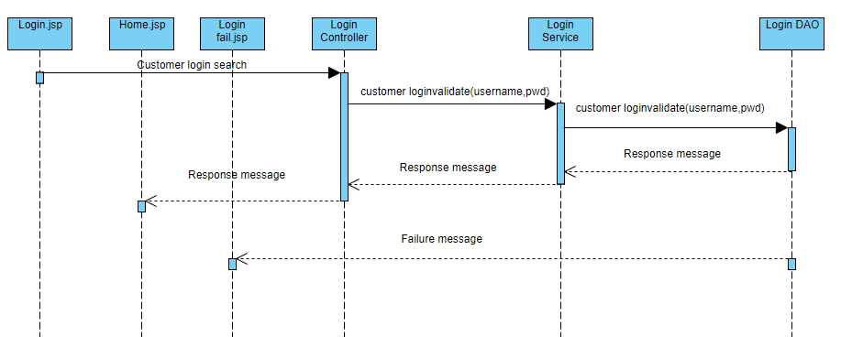

**Place Order:**

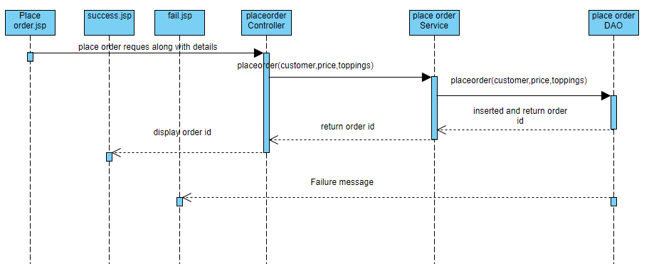

**Delete Order:**

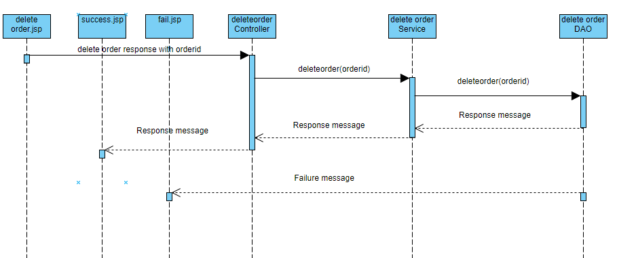

**Update Order:**

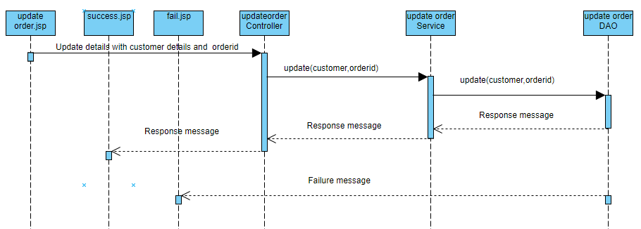

**Display Order:**

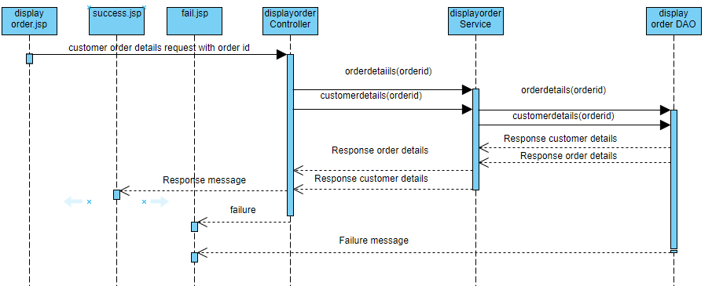

**Project Diagrams:**

**Login Page:** User enters credentials

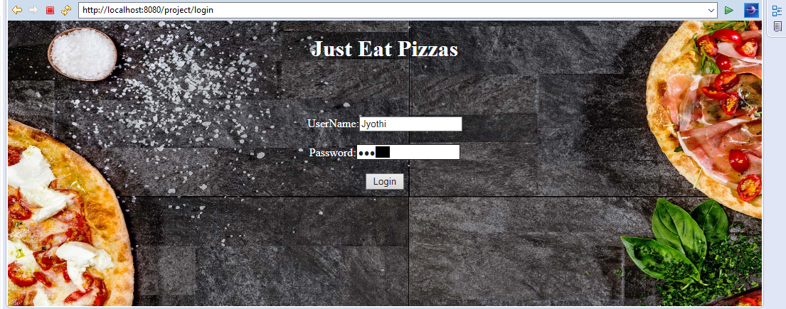

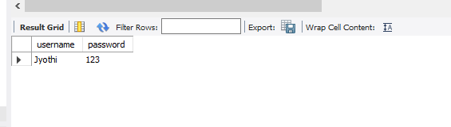

**Home Page:** After Login success user enter into home page

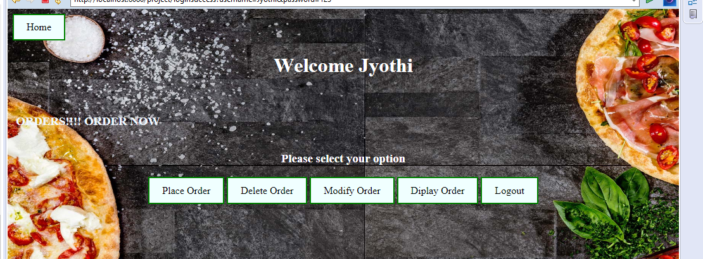

**Place Order:** User fills data to place order and order is successfully placed and also details are reflects in database

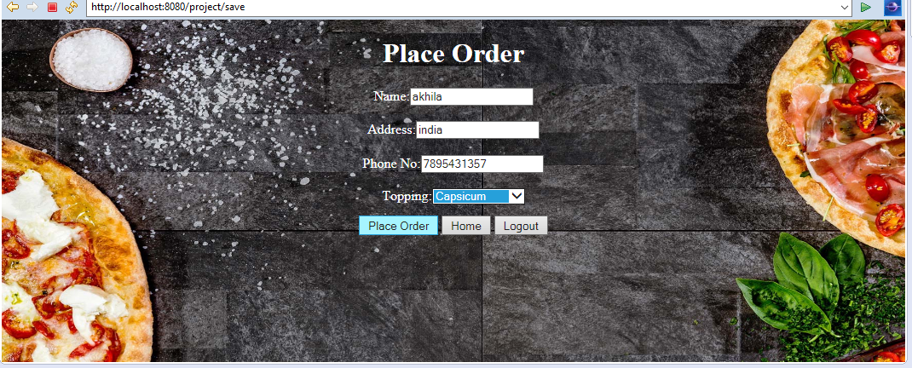

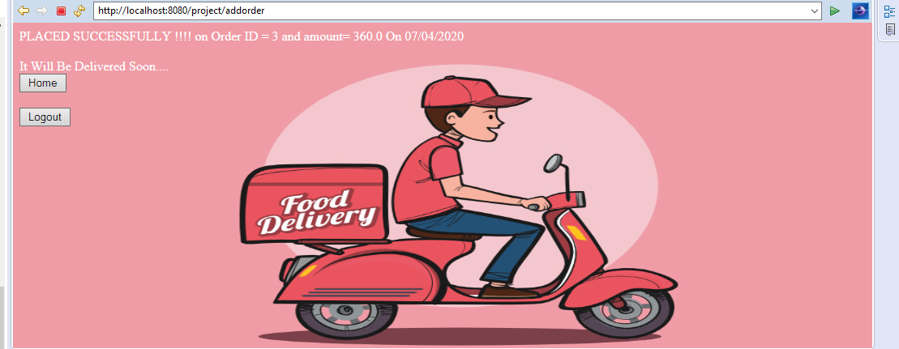

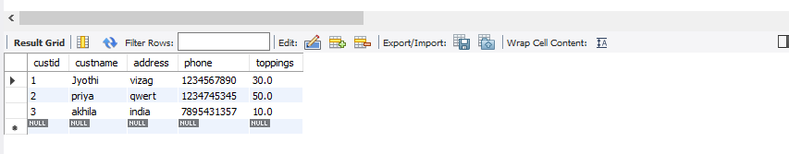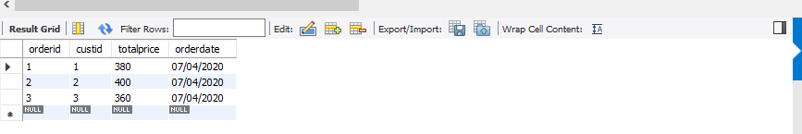

**Modify order:** User modifies order details by entering ordered and it is reflected in database





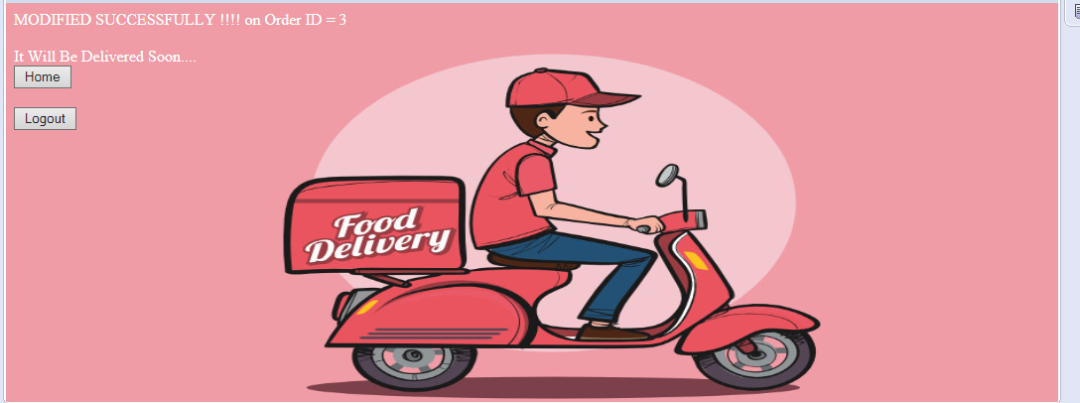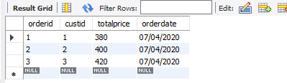

**Display Order:** User enters order id and details are displayed



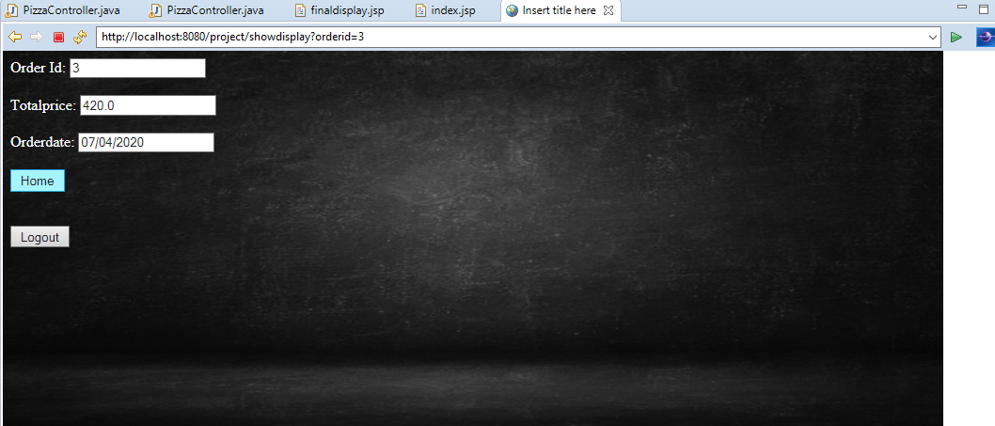

**Delete Order:** User deleted order by entering order id and it is reflected in database

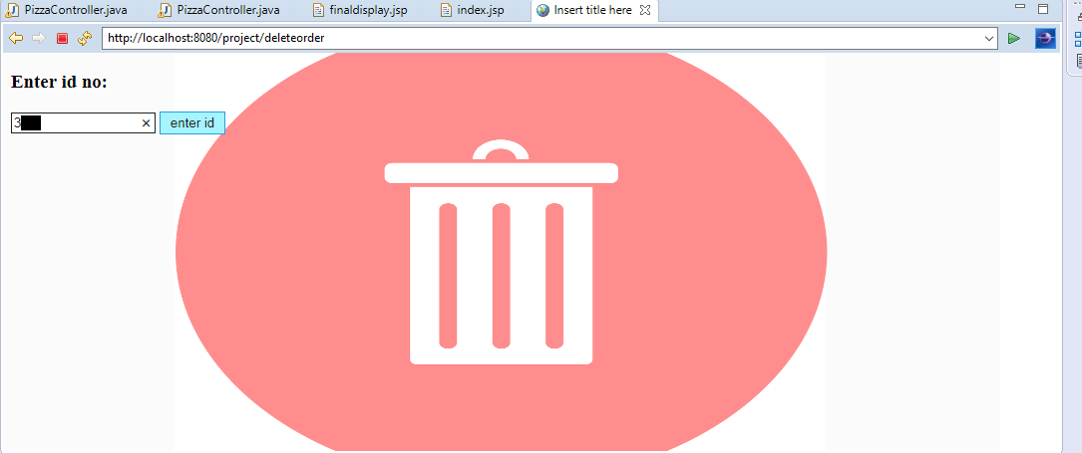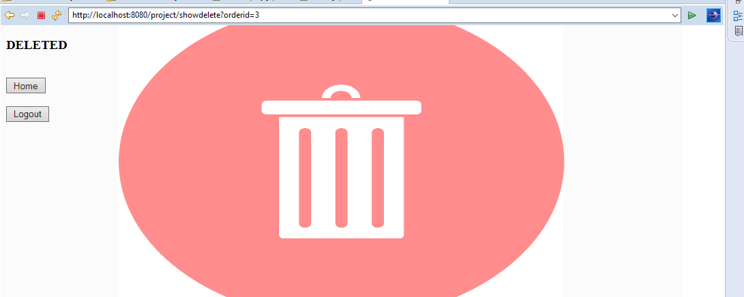

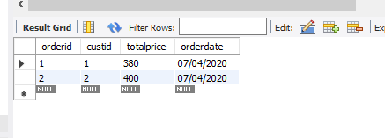

**Error Page:** If entered order id is wrong or not in database then it displays error

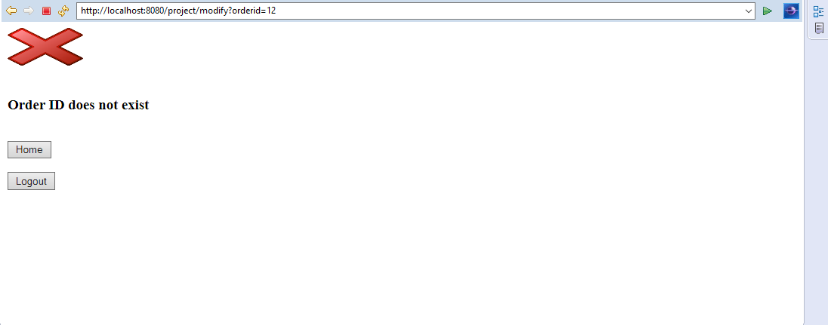**Logout:**

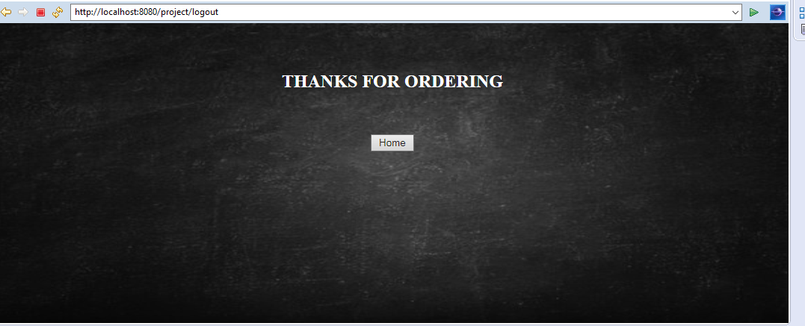

**CONCLUSION AND FUTURE WORK**

This Project provides basic functionalities to place and order .It is User friendly and allows user to change order details. More functionalities can be added like new registration where new users can register, view customer details, payment mode for customer to pay online, more order options like different pizzas, track the order and option to modify customer details.

**REFERENCES**

<https://www.javatpoint.com/spring-mvc-tutorial>

<http://websystique.com/springmvc/spring-4-mvc-and-hibernate4-integration-example-using-annotations/>

<https://examples.javacodegeeks.com/enterprise-java/spring/mvc/spring-mvc-hibernate-tutorial/>